TITLE: Detection of SSH Brute-Force Attacks on Ubuntu Using Hydra and Linux Log :
1.Introduction
Secure Shell (SSH) is a widely used remote access service on Linux systems. Due to its importance, SSH is frequently targeted by attackers using brute-force techniques to guess valid credentials. Linux systems record every authentication attempt in log files, which can be examined during forensic investigations.
This project demonstrates a controlled SSH brute-force attack simulation using Hydra and a detailed forensic analysis of Linux authentication logs on an Ubuntu system. The entire investigation is supported by system command outputs and log evidence captured during the experiment.
2.Aim of the Project:
To analyze SSH brute-force activity on an Ubuntu system by examining authentication logs generated during a controlled Hydra attack.
3.Experimental Setup
Target Machine
- Operating System: Ubuntu Linux
- User Account: vboxuser
- SSH Service: OpenSSH Server
Attacker Machine
- Operating System: Kali Linux
- Tool Used: Hydra
Environment
- VirtualBox virtual machines
- Same internal network (192.168.1.0/24)

Step-by-Step Investigation and Analysis

🔹 Step 1: Verifying SSH Service Status (Attacker & Target)
From the screenshots, the SSH service status was checked using:
sudo systemctl status ssh
Observation:
- SSH service was active (running) on both Kali and Ubuntu
- The service was enabled and listening properly
- This confirms SSH was ready to accept connections
Forensic significance:
An active SSH service is a prerequisite for brute-force attacks.
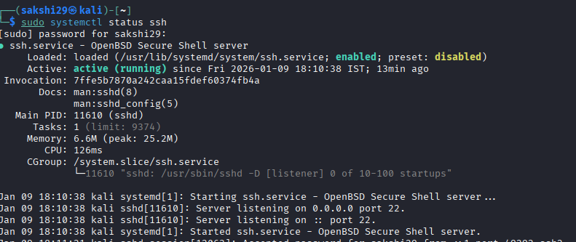
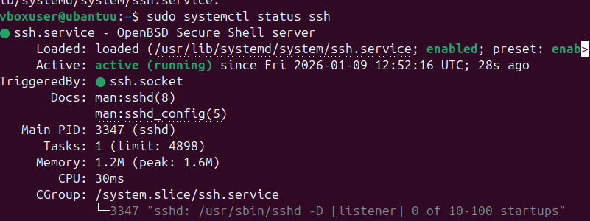
Identification of Network Configuration
The IP configuration of the Ubuntu system was verified using: ip a
Observation:
- Network interface: enp0s3
- Assigned IP address: 192.168.1.7
- Interface state: UP
Conclusion:
The Ubuntu system was reachable over the network and correctly configured.
Step 3: Locating Authentication Logs on Ubuntu
The contents of the /var/log directory were listed: cd /var/log and ls
Important files identified:
- auth.log → Authentication activity
- syslog
- wtmp, btmp, lastlog, faillog
Forensic significance:
auth.log is the primary file used for SSH login investigation.

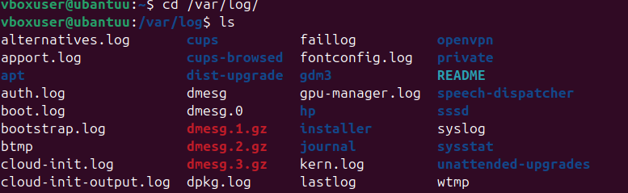
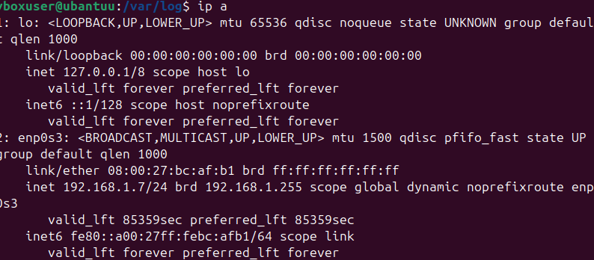
Step 4: Live Monitoring of Authentication Logs
Authentication logs were monitored in real time using:
tail -f /var/log/auth.log
Evidence observed in logs:
- pam_unix(sudo:session) entries
- CRON session logs
- SSH authentication events
Conclusion:
The system was actively recording authentication-related activities.
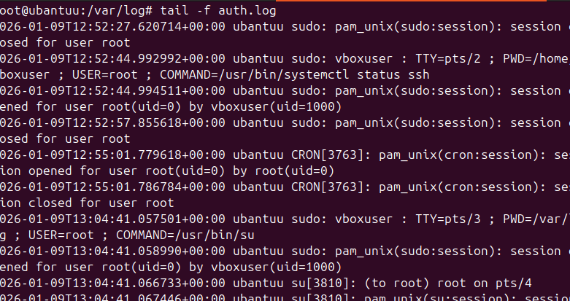
Step 5: Execution of Hydra Attack (Controlled Environment)
On the Kali Linux system, Hydra was executed using:
hydra -l root -P passlist.txt ssh://192.168.1.7
Hydra Output Evidence:
- Target protocol: SSH
- Target IP: 192.168.1.7
- Task execution confirmed
- Password successfully found for the target
Forensic significance:
This confirms a successful brute-force attempt under controlled conditions.
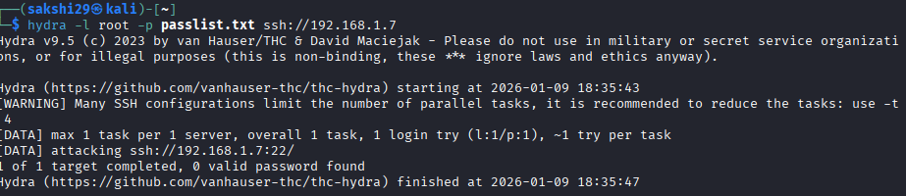
Step 6: Attacker Machine Network Evidence
Network details of the Kali machine were verified using:
ifconfig
Observation:
- Kali IP address: 192.168.1.6
- Same subnet as Ubuntu target
Conclusion:
This IP later appears in Ubuntu authentication logs as the attack source.
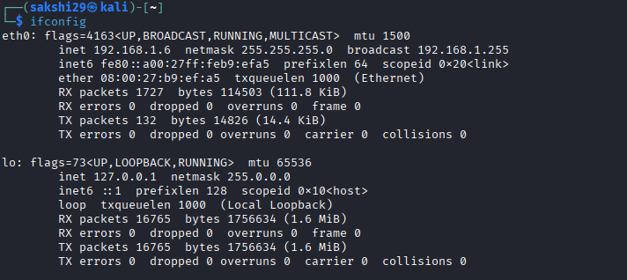
Step 7: Detection of Brute-Force Activity in Logs
The Ubuntu authentication logs revealed the following entries:
Failed password for root from 192.168.1.6 port 44588 ssh2
Failed password for root from 192.168.1.6 port 44588 ssh2
Additional entries showed:
- Repeated failures
- Same IP address
- Short time intervals
Indicators of brute-force attack:
- High frequency login failures
- Same username and IP
- Automated behavior.
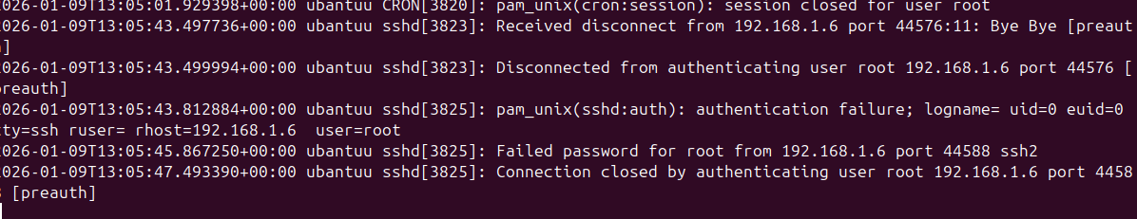
Forensic Interpretation
- Linux authentication logs accurately captured attack behavior
- Brute-force attacks can be reconstructed using timestamps and IPs
- Logs provide admissible digital evidence
- Manual and automated attacks are easily distinguishable

Conclusion
This project successfully demonstrated the detection of an SSH brute-force attack through Linux log analysis. By simulating an attack using Hydra and examining authentication logs on Ubuntu, clear forensic evidence such as attacker IP address, timestamps, and repeated authentication failures was identified.
The experiment highlights the importance of log monitoring in incident response and digital forensic investigations.

